**Task 1: Use the Previously Connected VMs**

1. **Log in to the Azure Portal:**
   * Go to [Azure Portal](https://portal.azure.com).
2. **Access Your Virtual Machines:**
   * In the left sidebar, click on "Virtual machines."
   * Here, you’ll see a list of all the VMs associated with your account. Click on the VM you want to connect to.
3. **Connect to the VM:**

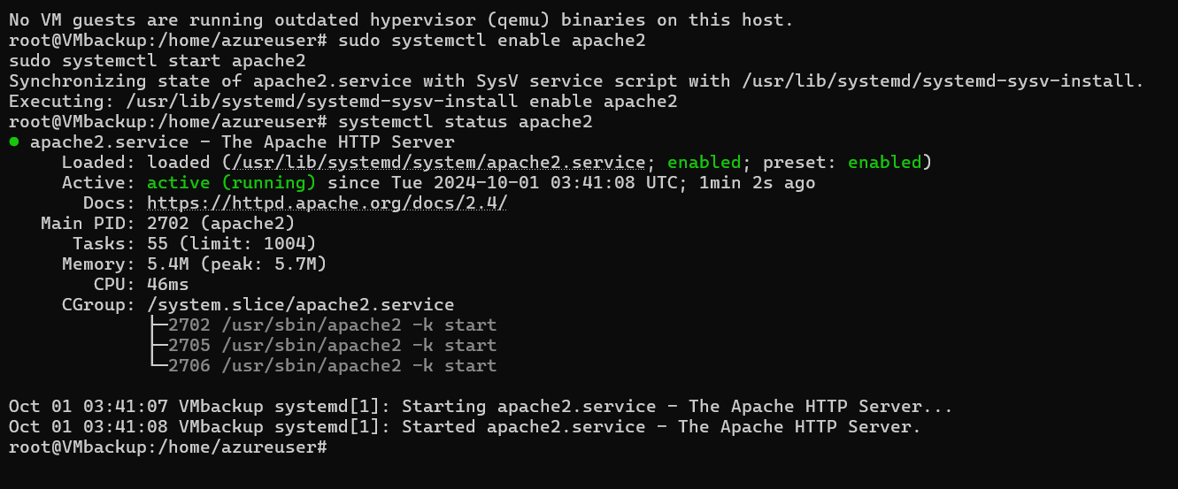

**Task 2: Connect Log Analytics to This Virtual Machine**

1. **Install the Log Analytics Agent**:
   * On the VM's page, scroll down to the **Monitoring** section and select **Insights**.
   * Click **Enable**.

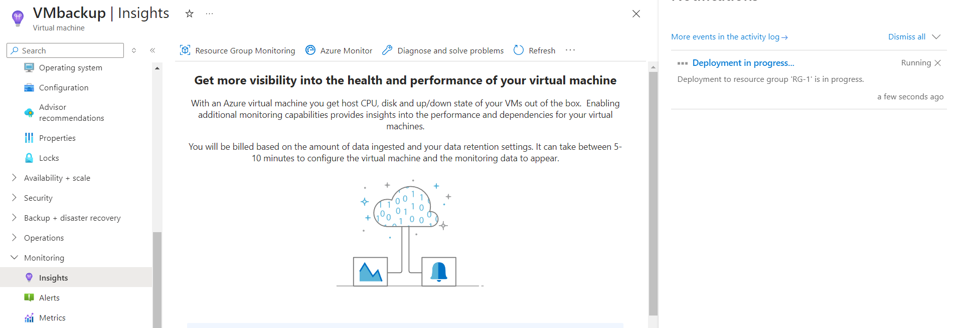

1. **Verify the Connection**:
   * To check if logs are being collected, go to **Logs** in the workspace and query the logs from your VM.

